As weather wipes out Fort Worth race, Cistercian priest feeds Cowtown Marathon habit in Hungary
Facebook | Twitter | Email | Comment | Print
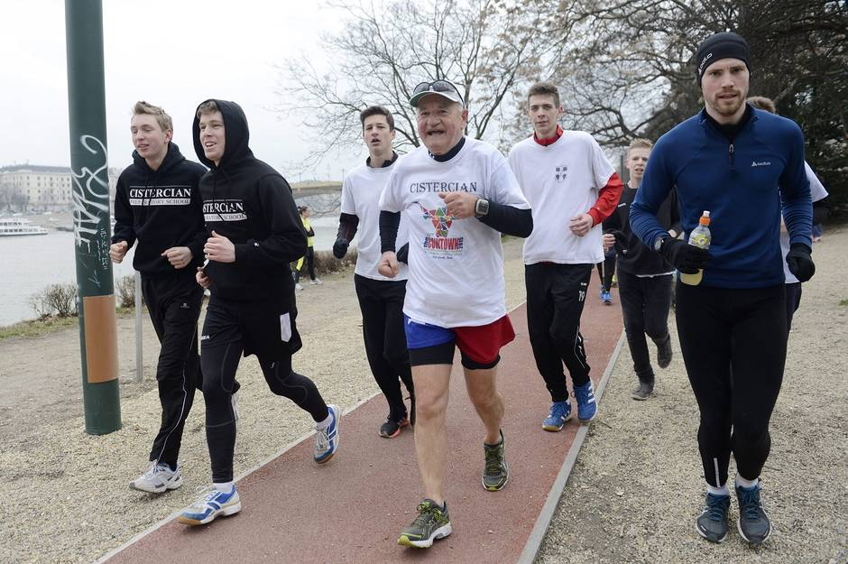
Tamás Kovács/MTVA
To keep up his streak of Cowtown Ultra races, the Rev. Bernard Marton of Cistercian Preparatory School in Irving got the blessing to run the 2015 Cowtown Ultra in Budapest, Hungary. Marton, who is on sabbatical there, was joined Sunday by students, faculty and friends. The Fort Worth version was called off.

By DEBORAH FLECK dfleck@dallasnews.com
Staff Writer
Published: 03 March 2015 12:59 PM
Updated: 03 March 2015 01:06 PM
The only runner to complete this year’s Cowtown Ultra Race was the Rev. Bernard Marton.
With the cancellation of the race Sunday because of bad weather, the Cistercian Catholic priest had to finish it virtually. Of course.
Marton, 73, didn’t want to break his streak of six consecutive Cowtown Ultra races. He asked race director Heidi Swartz about running the distance in Budapest, Hungary. He’s there on a semester-long sabbatical from Cistercian Preparatory School in Irving.
She gave him the OK and sent his bib electronically.
So, under partly cloudy skies with temperatures in the 50s, Marton completed his seventh Cowtown Ultra. He finished in 7 hours, 37 minutes on Sunday.
“The deed is done,” Marton wrote on his Facebook page. “Very happy about a super day.”
He didn’t run alone.
“Oodles of my students, faculty members and alumni from the school where I’m now teaching ESL joined me in a relay,” Marton said in an email.
He also attracted lots of media attention.
“Two TV stations hunted me down and covered many miles with me,” he said.
He ran not only to keep his record intact but also in memory of three men who influenced his life: his brother, the Rev. Henry Marton; his former teacher, Károly Munkács; and beloved Cistercian coach Tom Hillary

